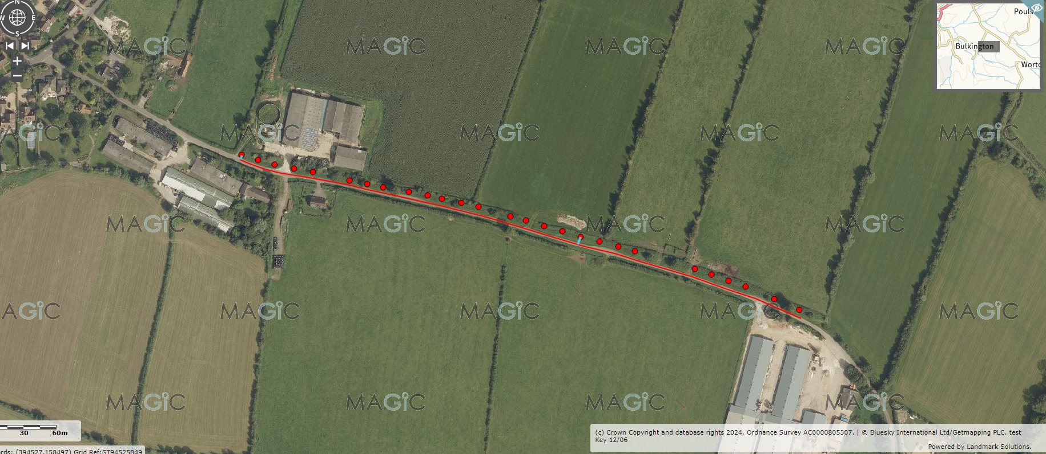
Mill Lane Blossom Trail
Mixed blossoming species
No. 27 @ 15 metre spacings at min 4.5 metres from road centre

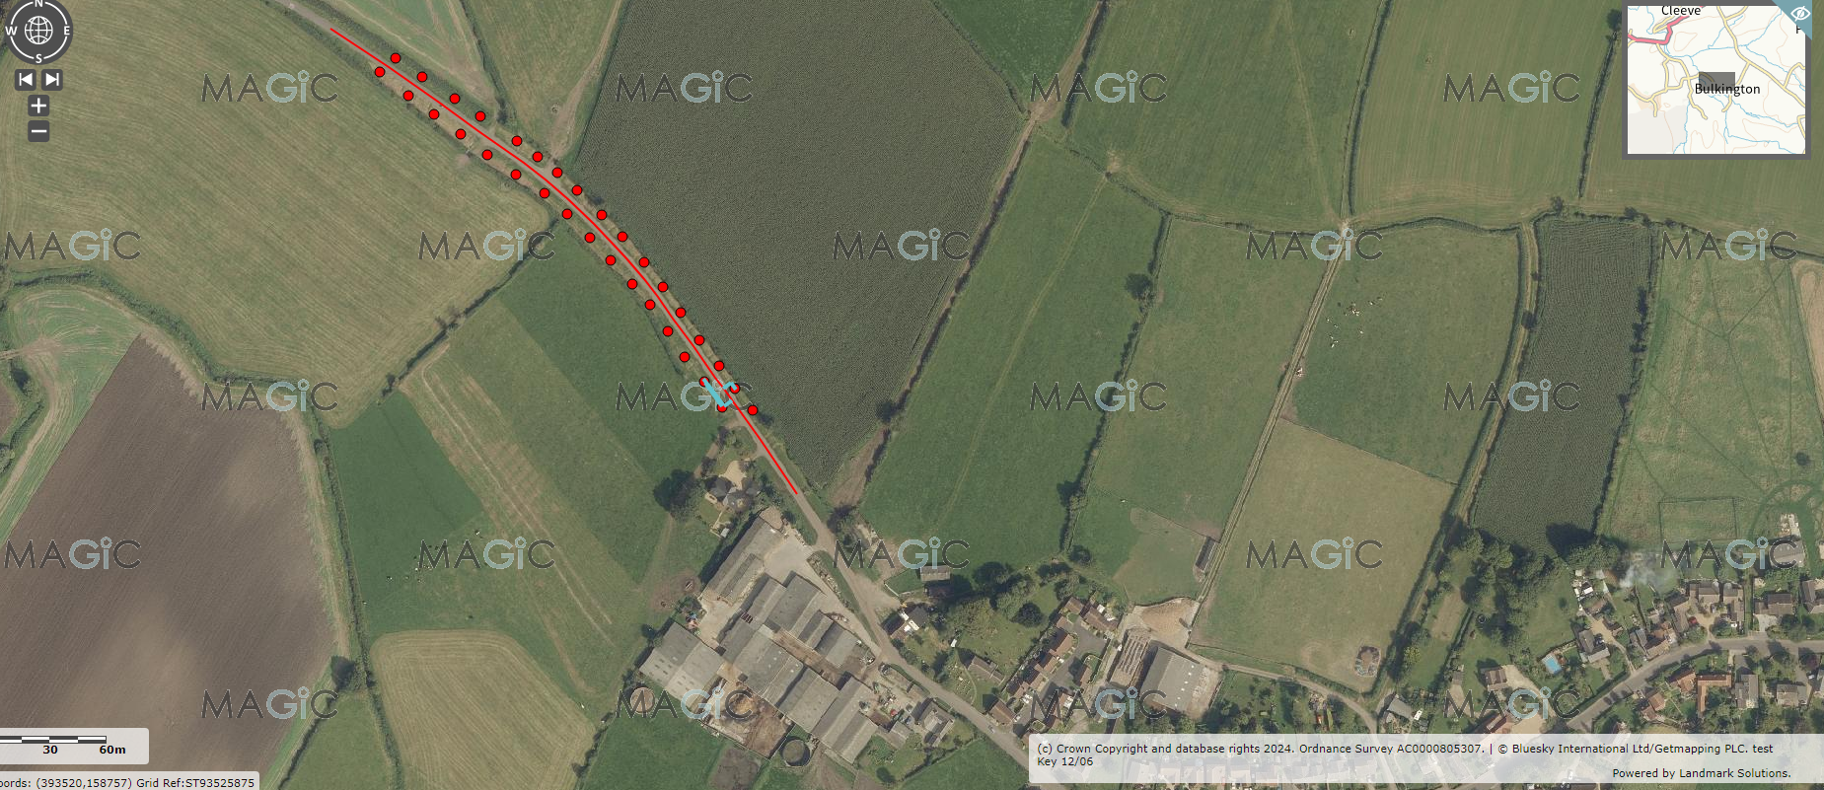
Bulkington High Street Re-elming
Disease resistant elms
No circa 33 @ 15 metre spacings minimum 4.5 metres from road centre avoiding WC drainage grips

